Prevention Conference 2021 | 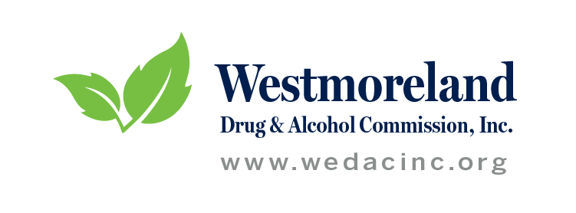  - 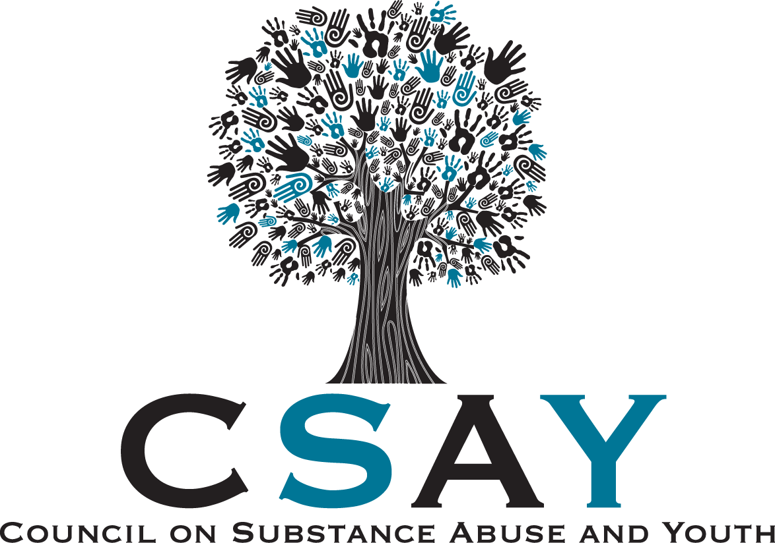
Friday, October 1, 2021  Topics Include  - Mental Health and Substance Abuse Issues with Comedian Gab Bonesso  - Impaired Driving in PA with a focus on Medical Marijuana with PA DUI Association and PSP Trooper Tappe  - ACES surrounding Substance Use Disorder presented by Tory Hough  - Q & A with a panel of Certified Recovery Specialists  8:45 AM—3:45 PM  Westmoreland County  Community College  Contact Info  724.542.4508  sopalinski@wedacinc.org | FREE EVENT  For Participants  Lunch is Provided
PARTICIPANTS REGISTER AT HTTPS://WWW.SURVEYMONKEY.COM/R/PREVENTIONCONFERENCE2021
VENDOR TABLES AVAILABLE FOR $25 REGISTRATION FEE. VENDORS MAY REGISTER AT HTTPS://WWW.SURVEYMONKEY.COM/R/PREVCONF2021VENDORS

VENDOR TABLES AVAILABLE FOR $25 REGISTRATION FEE.
REGISTER AT WWW.WEDACINC.ORG/PREVENTIONCONFERENCE

