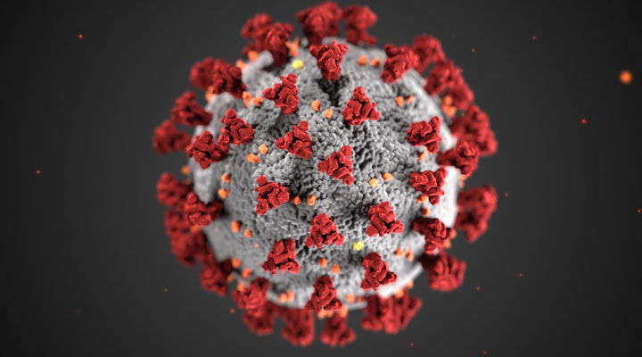
As people across the U.S. and the rest of the world contend with coronavirus disease 2019 (COVID-19), the research community should be alert to the possibility that it could hit some populations with substance use disorders (SUDs) particularly hard. Because it attacks the lungs, the coronavirus that causes COVID-19 could be an especially serious threat to those who smoke tobacco or marijuana or who vape. People with opioid use disorder (OUD) and methamphetamine use disorder may also be vulnerable due to those drugs’ effects on respiratory and pulmonary health. Additionally, individuals with a substance use disorder are more likely to experience homelessness or incarceration than those in the general population, and these circumstances pose unique challenges regarding transmission of the virus that causes COVID-19. All these possibilities should be a focus of active surveillance as we work to understand this emerging health threat.
SARS-CoV-2, the virus that causes COVID-19 is believed to have jumped species from other mammals (likely bats) to first infect humans in Wuhan, capital of China’s Hubei province, in late 2019. It attacks the respiratory tract and appears to have a higher fatality rate than seasonal influenza. The exact fatality rate is still unknown, since it depends on the number of undiagnosed and asymptomatic cases, and further analyses are needed to determine those figures. Thus far, deaths and serious illness from COVID-19 seem concentrated among those who are older and who have underlying health issues, such as diabetes, cancer, and respiratory conditions. It is therefore reasonable to be concerned that compromised lung function or lung disease related to smoking history, such as chronic obstructive pulmonary disease (COPD), could put people at risk for serious complications of COVID-19.
Co-occurring conditions including COPD, cardiovascular disease, and other respiratory diseases have been found to worsen prognosis in patients with other coronaviruses that affect the respiratory system, such as those that cause SARS and MERS. According to a case series published in JAMA based on data from the Chinese Center for Disease Control and Prevention (China CDC), the case fatality rate (CFR) for COVID-19 was 6.3 percent for those with chronic respiratory disease, compared to a CFR of 2.3 percent overall. In China, 52.9 percent of men smoke, in contrast to just 2.4 percent of women; further analysis of the emerging COVID-19 data from China could help determine if this disparity is contributing to the higher mortality observed in men compared to women, as reported by China CDC. While data thus far are preliminary, they do highlight the need for further research to clarify the role of underlying illness and other factors in susceptibility to COVID-19 and its clinical course.
Vaping, like smoking, may also harm lung health. Whether it can lead to COPD is still unknown, but emerging evidence suggests that exposure to aerosols from e-cigarettes harms the cells of the lung and diminishes the ability to respond to infection. In one NIH-supported study, for instance, influenza virus-infected mice exposed to these aerosols had enhanced tissue damage and inflammation.
People who use opioids at high doses medically or who have OUD face separate challenges to their respiratory health. Since opioids act in the brainstem to slow breathing, their use not only puts the user at risk of life-threatening or fatal overdose, it may also cause a harmful decrease in oxygen in the blood (hypoxemia). Lack of oxygen can be especially damaging to the brain; while brain cells can withstand short periods of low oxygen, they can suffer damage when this state persists. Chronic respiratory disease is already known to increase overdose mortality risk among people taking opioids, and thus diminished lung capacity from COVID-19 could similarly endanger this population.

Issue # 2 March 31th, 2020

PrEve
ntion
News

COVID-19: Potential Implications for Individuals with Substance Use Disorders Information Courtesy of: SAMHSA.GOV

Podcasts

Shoestring Mindfulness: How Much Does It Cost To Change The World

Positive Self Talk Podcast
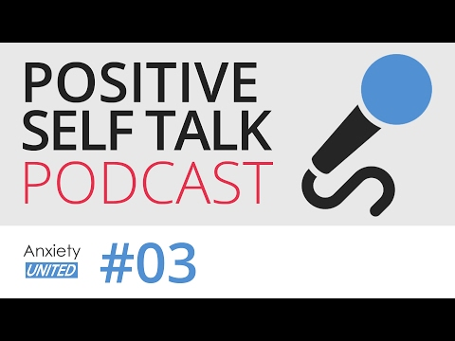

New Biological Clues
A history of methamphetamine use may also put people at risk. Methamphetamine constricts the blood vessels, which is one of the properties that contributes to pulmonary damage and pulmonary hypertension in people who use it. Clinicians should be prepared to monitor the possible adverse effects of methamphetamine use, the prevalence of which is increasing in our country, when treating those with COVID-19.
Other risks for people with substance use disorders include decreased access to health care, housing insecurity, and greater likelihood for incarceration. Limited access to health care places people with addiction at greater risk for many illnesses, but if hospitals and clinics are pushed to their capacity, it could be that people with addiction—who are already stigmatized and underserved by the healthcare system—will experience even greater barriers to treatment for COVID-19. Homelessness or incarceration can expose people to environments where they are in close contact with others who might also be at higher risk for infections. The prospect of self-quarantine and other public health measures may also disrupt access to syringe services, medications, and other support needed by people with OUD.
We know very little right now about COVID-19 and even less about its intersection with substance use disorders. But we can make educated guesses based on past experience that people with compromised health due to smoking or vaping and people with opioid, methamphetamine, cannabis, and other substance use disorders could find themselves at increased risk of COVID-19 and its more serious complications—for multiple physiological and social/environmental reasons. The research community should thus be alert to associations between COVID-19 case severity/mortality and substance use, smoking or vaping history, and smoking- or vaping-related lung disease. We must also ensure that patients with substance use disorders are not discriminated against if a rise in COVID-19 cases places added burden on our healthcare system. As we strive to confront the major health challenges of opioid and other drug overdoses—and now the rising infections with COVID-19—NIDA encourages researchers to request supplements that will allow them to obtain data on the risks for COVID-19 in individuals experiencing substance use disorders.
Information Courtesy of www.samhsa.gov
Linking Social connectedness
To Reduced drug craving
And relapse

Information courtesy of National Institute on Drug Abuse
The current study offers the first mechanistic explanation for the protective effect of social interaction on incubation of craving in rodents, showing that it is mediated by the activation of neurons expressing the enzyme PKCδ in one part of the brain’s amygdala. The scientists also found that activation of a peptide called somatostatin in the amygdala is critical for incubation of drug craving following forced abstinence. In addition, these researchers introduced novel viral tools that will allow other researchers to mechanistically study the role of PKCδ and somatostatin in learned and motivated behaviors related to drug use disorders, as well as other psychiatric disorders.
The rat social choice model used by this team already has clinical implications, with several researchers initiating human studies on brain mechanisms of choice between rewarding social interactions and addictive drugs. Scientists hope that these new findings will stimulate more human research into how social-based treatment approaches might help restore normal amygdala function, resulting in reduced relapse risk.
The research was done by NIDA intramural scientists in collaboration with the Messing lab at the University of Texas in Austin.

Research published by Marco Venniro and NIDA colleagues in 2018 found that positive social interaction in rats prevents drug self-administration. When given a choice between interacting with another rat or taking heroin or methamphetamine, the rats consistently chose the social reward.
The researchers also examined the effect of social interaction on incubation of drug craving, a phenomenon in which drug seeking progressively increases after they are no longer given access to drugs—similar to what many human drug users experience during drug abstinence. The researchers provided rats who had been trained to self-administer an addictive drug with a choice between the drug or a rewarding social interaction and found that the rats chose the social reward over the drug. Moreover, the rats who chose to abstain from drugs—as opposed to forced abstinence—were protected against incubation of drug craving.
Have you ever wondered if all that smartphone scrolling, s the
“screen time”—time spent looking at smartphone,

computer, and television screens—changes the developing brain.
Past research has shown differences in the brains of young adults who spend a lot of time playing video games, compared with those who don’t. Scientists want to learn more about how screen time affects the younger brains of children and teens.
Brain scans from the Adolescent Brain Cognitive Development (ABCD) Study showed a difference in the brains of some 9- and 10-year-olds who use smartphones, tablets, and video games more than 7

Eventually, researchers hope to find out if and how screen time is connected to changes in the developing brain.
Screen time is just one of the things scientists are exploring

Webinars Brought to you by
The Westmoreland Drug and Alcohol Commission, Inc.
AND

Webinar Opportunities
SVCPP Gregg Norton-Vaping Updates
Friday April 3, 2020
https://www.surveymonkey.com/r/NDKH8DT
Juvenile Probation Michele Wentzel-Sexting issues
Thursday April 9th 10:00 AM

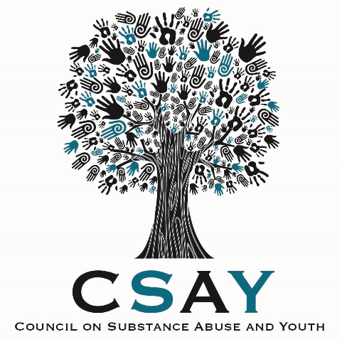

Thank you to ALL the first Responders who help to make a difference every single day regardless of the circumstances. Watch Video and help to celebrate those who risk their lives to save ours!

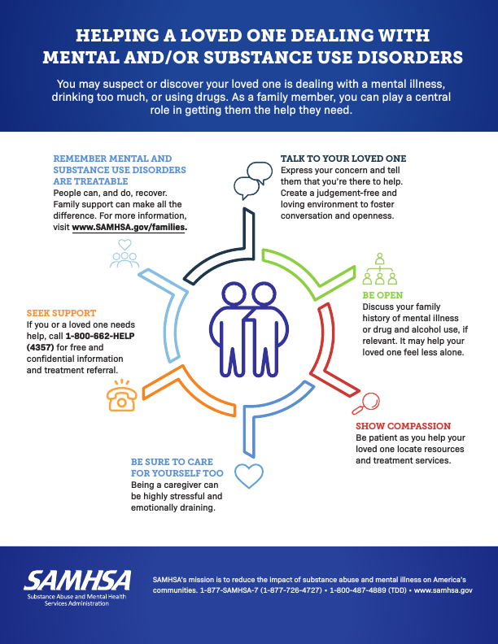
March 30th – April 5, 2020
Is National Drug & Alcohol Facts Week
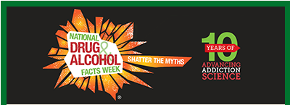

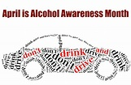
National Drug and Alcohol Facts Week® links students with scientists and other experts to counteract the myths about drugs and alcohol that teens get from the internet, social media, TV, movies, music, or from friends. It was launched in 2010 by scientists at the National Institute on Drug Abuse (NIDA) to stimulate educational events in communities so teens can learn what science has taught us about drug use and addiction. The National Institute on Alcohol Abuse and Alcoholism became a partner in 2016, and alcohol has been added as a topic area for the week. NIDA and NIAAA are part of the National Institutes of Health.
FACT OF THE DAY WEDNESDAY APRIL 1
If you smoke marijuana a lot in your teens, you could lose IQ points (which measure intelligence) that you might never get back.
Can Smoking Marijuana Actually Lower Your IQ?
Many teenagers assume smoking weed is harmless because of all the myths floating around saying it’s safe. What few people know is that the age you start using marijuana actually makes a difference. In fact, if you start smoking it as a teenager, there can be some serious problems for you down the road.
Although we already knew from past research that if you start smoking pot as a teen, you’ll be more likely to get addicted, new research (just published in a well-known journal called Proceedings of the National Academy of Sciences) now says if you smoke marijuana heavily as a teenager, it can actually lower your IQ!
Scientists looked at more than 1,000 people born in 1972 and 1973. When they were 13 years old, they were given IQ and other kinds of intelligence tests. They were interviewed every few years about their use of marijuana and then tested again when they were 38 years old.
The results? Those who smoked weed heavily as teens showed mental decline even after they quit using the drug—and had, on average, an 8-point drop in their IQ scores. An 8-point loss could push a person of average intelligence into the lower third of testers. Those who started smoking pot after age 18 also showed some decline, but not as much.
This was an interesting study because it also collected information from people who knew the study participants. They reported that people who smoked marijuana heavily had more memory and attention problems and did not organize their lives as well, misplacing things and forgetting to keep appointments, pay bills, or return calls. This highlights the lasting effect marijuana can have on the teenage brain, which is still developing and still wiring itself to handle the onslaught of information it gets every day. The toxic chemicals in marijuana can mess up that wiring process and hurt your ability to do well in school and in life.

